L.N.Gumilyov Eurasian National University

Faculty of Information Technology

Departament of «Information Systems»

REPORT

**Midterm 2**

Student: Seitzhanova Altyn

Group: IS-21

______________

Supervisor: PhD, Tamara Kokenovna Zhukabayeva

______________

Astana, 2024

**Introduction**

In the era of digitalization the massive growing significance of technology in the travel industry and the growing demand from travel agencies for effective management systems make the study issue relevant. Customers require easy online booking processes and tailored suggestions based on their interests in this digital era. Therefore, in order to match these changing consumer expectations and maintain market competitiveness, travel firms must establish a database specifically designed for them.

Travel agencies have a rich history that can be traced back to the 19th century when the advent of railways and steamships made travel more accessible to the masses. These agencies emerged as intermediaries, providing travelers with guidance, arranging transportation, accommodations, and itineraries. Over the decades, as modes of transportation evolved and destinations expanded, so did the scope and services of travel agencies. They became synonymous with personalized service, expertise, and convenience. As we have travel agencies to make our lives easier, we should have database of travel agencies.

In this project that we created, we provide a help for people and businesses that struggle to maintain available travel products such as flights, hotels, rental cars, tours, and activities. And also, to keep track of financial transactions, including payments received from customers, payments made to suppliers, commissions earned, and overall revenue and expenses. Making easier to maintain details of your supplier contacts, contracts, pricing agreements, and performance metrics. In addition, helping to customers in analyzing data and booking patterns to identify trends, preferences, and opportunities for targeted marketing campaigns.

## GitHub and Jira

Jira, an innovative project management solution, and GitHub, a popular collaborative software development platform, have proven to be the perfect match for our needs. They have provided effective means of planning, tracking and managing the project. The information received helped to solve problems, determine priorities, set deadlines and appoint responsible people in Jira. At the same time, GitHub allowed you to control code versions, work together on development and share changes in the project.

Having fully realized the value of the platforms, it is planned to continue using Jira and GitHub in the future. They are an integral part of the software development industry and are widely in demand in the professional community. Jira and GitHub provide reliable and convenient tools for effective project management, ensuring synchronization of team work and facilitating the process of joint development..

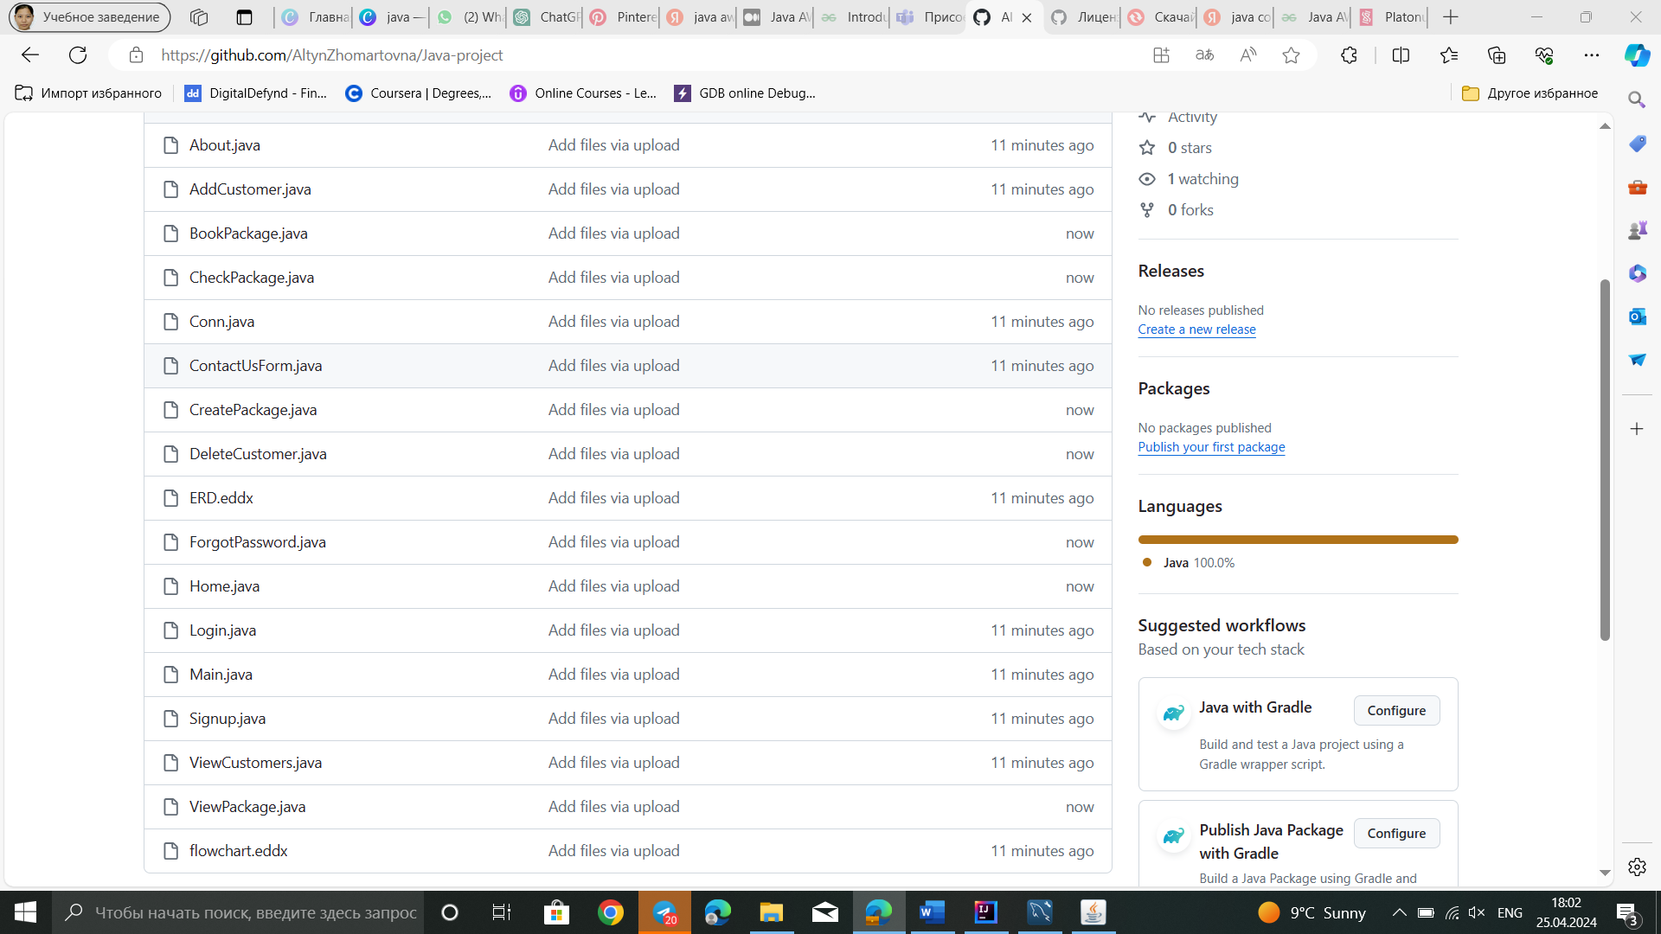

Picture.1.GitHub.

## Jira

A plan was drawn up for a grandiose task, with many tiny components, where the individual characteristics of each were taken into account. Jira, a powerful project management tool developed by Atlassian, is an excellent choice in this difficult task. Jira, widely used to coordinate work, track bugs, and manage tasks in the development team. It allows you to create and monitor tasks, set priorities, set deadlines, and assign responsible performers. This gives efficiency in planning, organizing and monitoring the progress of work. The visual implementation of our plans in Jira has become not only superbly structured, but also delightfully visual.

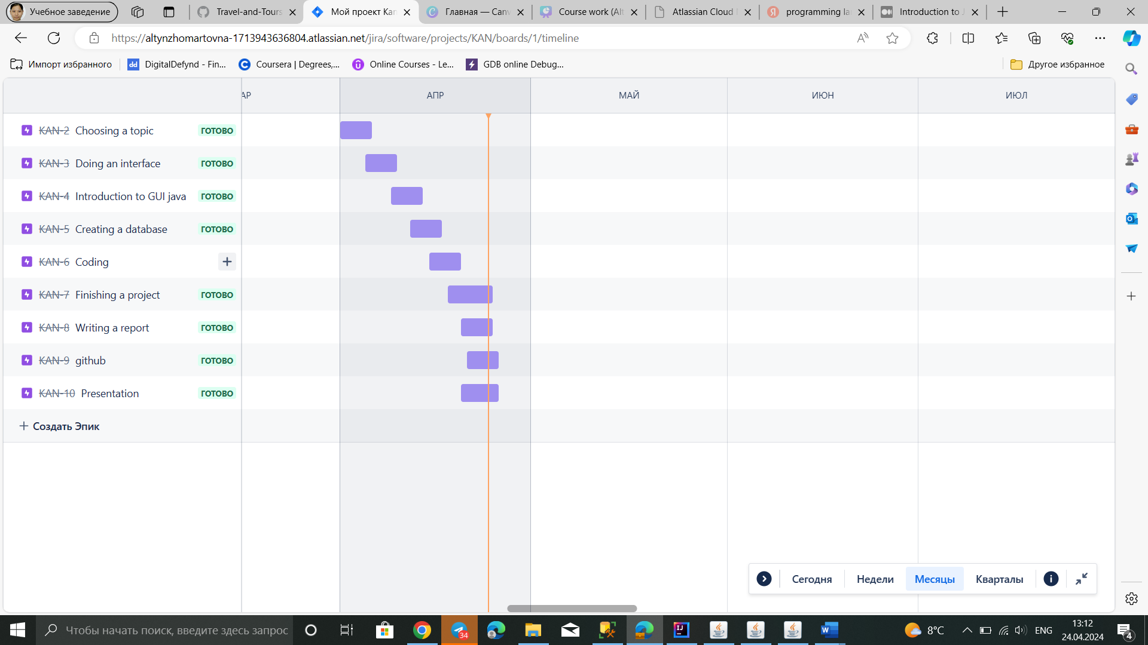

Picture 2. Plan

## Characteristics of object area

To restore inner calm, energy, and mental fortitude, it might sometimes be beneficial to walk outside and get some fresh air. This is the rationale behind the large number of travelers. While it can be quite beneficial to organize and arrange your complete trip itinerary on your own, there are occasions when we would like to delegate that task to a travel agency. Therefore, if you're planning a trip, there are many of travel companies out there that are able to offer you with fantastic deals.

Travel agency is one of the most important organizations in the tourism private sector which plays a significant and crucial role in the entire process of developing and promoting tourism in the country or at a destination. It is a travel agency which packages and processes all the attractions, accesses, amenities and ancillary services of a country and present them to tourists. That’s why travel agency is known as ‘image builder’ of a country .A prospective travel agency is one which makes arrangements of travel tickets (air, rail, road, and sea); travel documents (passports, visa and other documents required to travel); accommodation, entertainment, and other travel-related services from principle suppliers. It may also secure travel insurance, foreign currency for traveling people. Travel companies can now operate locally, nationally, or internationally, catering to customers from a variety of geographic locations, thanks to the development of internet booking platforms and globalization.

# **Realisation**

## Progamming language Java

Java Programming is a general-purpose object-oriented programming language, designed for the development of software for consumer electronic devices such as TVs, VCRs, toasters, etc.

Java is a platform neutral language, which means it is not tied to any particular hardware or operating system. It guarantees users to ‘write once, run anywhere’. Java language is supported by almost every operating system such as Sun Solaris, RedHat, Windows etc.

The main goal of the inventors was to design a language which could offer solutions to the problems encountered in modern programming. The goal being the language to be reliable, portable and distributed and at the same time simple, compact and interactive.

a. Compiled and Interpreted

Java language combines both of these approaches thus making Java a two-stage system. This approach was never offered before, as any language before was either compiled or interpreted.

Firstly, Java compiler translates source code into bytecode instructions, bytecodes are not machine instructions.

Secondly, Java interpreter generates machine code that can be directly executed by the machine that is running the Java program.

b. Independent and Portable

Java programs can be easily moved from one system to another, anywhere and anytime. Changes or any upgrade in the operating system, processors and system resources will not force any changes in Java programs.

Java programming ensures portability in two ways: firstly, Java compiler generates bytecode instructions that can be implemented on any machine, and secondly, the size of the primitive data types are machine independent.

c. Object-oriented

Almost everything in Java language is an object, which makes it a true object-oriented language. All program code and data reside within objects and classes. Java comes with an extensive set of classes, arranged in packages, which are used in program inheritance.

d. Robust and Secure

Java language provides many safeguards to ensure reliable code. It has strict run-time checking for data types. It is designed as a garbage collected language, i.e., it captures series errors and eliminates any risk of crashing the system.

Java systems verify all the memory access and thus ensures that no virus is communicated with an applet.

e Distributed

Java programming facilitates both, sharing of data and programs. Java applications can open and access remote objects on Internet as easily as on any local system.

f. Simple, Small and Familiar

Java is a simplified version of C++, which is why it is familiar and yet different as it eliminates all the redundant and unreliable code. For example, Java does not use pointers, preprocessor header files, and many others. It also eliminates operator overloading and multiple inheritances in Java.

g. Multithreaded and Interactive

Multithreaded means handling different tasks simultaneously. Java language supports multithreaded programs, which means that we need not have to wait for one task to finish for another to start. This feature of java greatly improves the interactive performance of graphical applications.

h. High Performance

Java programming performance is very impressive considering the fact that is an interpreted language, mainly because of the bytecodes. Java architecture is designed to reduce overheads.

i. Dynamic and Extensible

Java is a dynamic language, it is capable of dynamically linking in new class libraries, methods, and objects. It can also determine the type of class through query.

j. Ease of Development

Java 2 standard edition (J2SE) 5.0 supports features such as Generics, Enhanced for loop, Autoboxing or unboxing, Typesafe enums, varargs, Static import and Annotation. These java features make it easy for the java programmer by shifting the responsibility of creating the reusable code to the compiler, and also the resulting code is free from bugs.

Output of code:

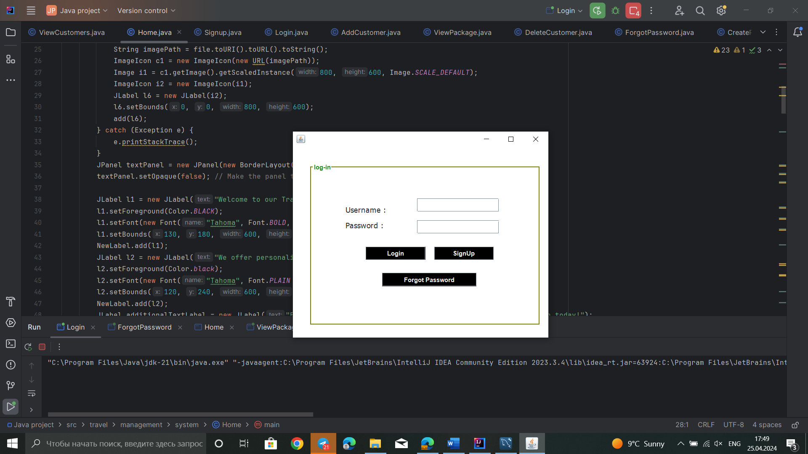

Picture 3. Log in Page

In login Page we have three buttons. First, of course , Login to system and Sign up in case you don’t have an account and Forgot Password button in case you forget your passwords

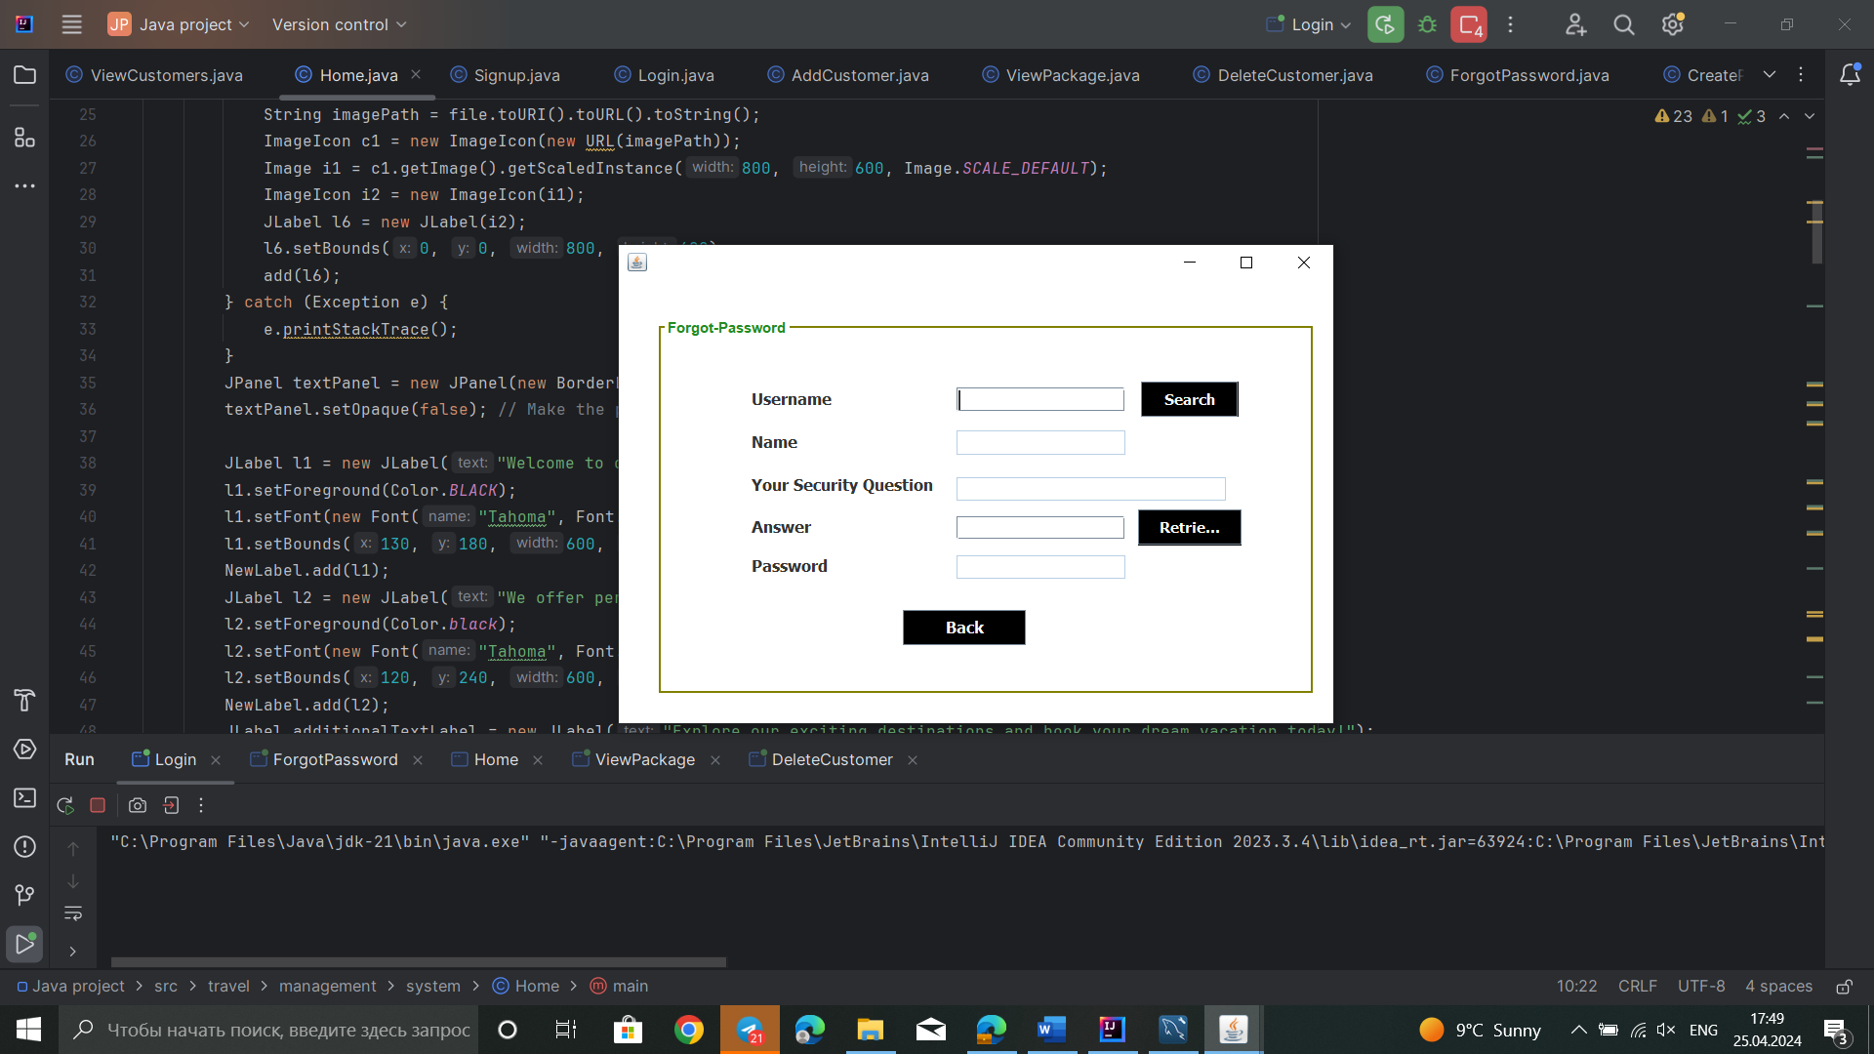

Picture 4. Forgot password

Forgot password page responsible for you to give a hint based on your chosen hint when Signing up. And if you get the your questions answer right, you will get your password.

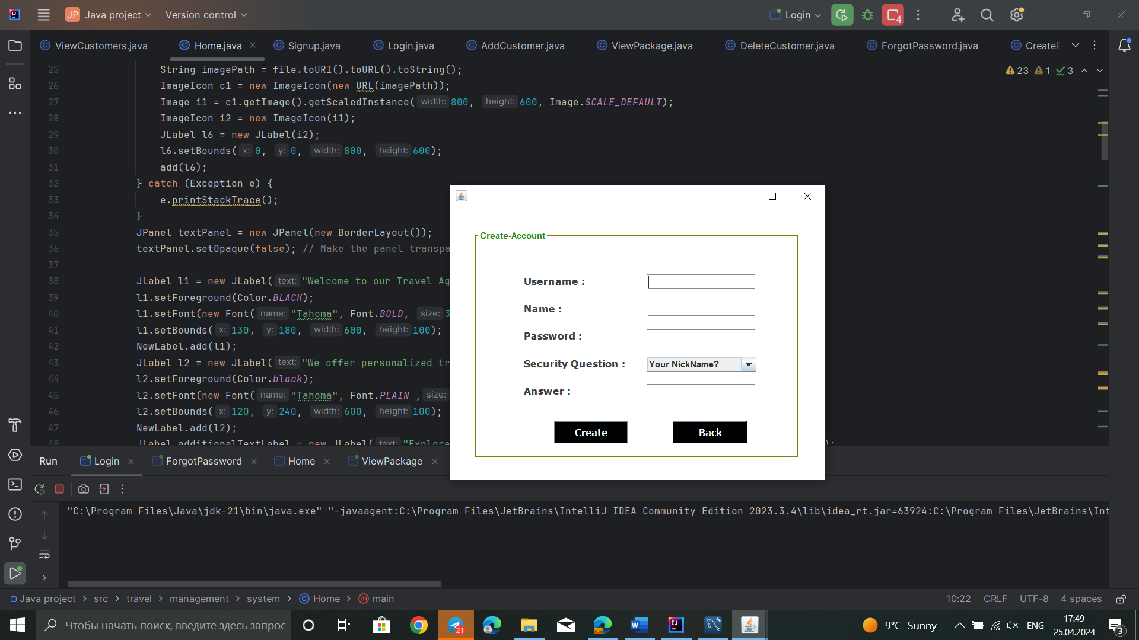

Picture 5. Sign Up

Sign up page creates a new account to our system and in case you forget your password gives a question to answer.

## 

## Picture 6. Home page

## Home page has menu that we get Customers, Packages, Contact, utility and about us information

## 

## Picture 7. View Customers

## 

## Picture 8. Delete Customers

## 

## Picture 9. Add new customer

## 

## Picture 10. Create Package

## 

## Picture 11. View Package Details

## SQL database

## 

## Picture 12. Customers

## 

## Picture 13. BookPackage

## We actually have also Users database that we use for signing in our system. But since it’s a new system we don’t have as many data as in Customers and Bookpackage tables.

## ERD and flow-chart

The UML of the project is shown below in Figure 5:

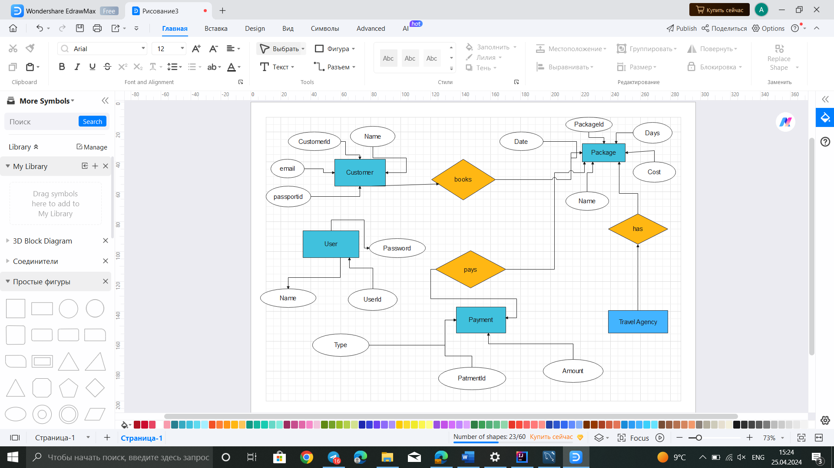

Picrure 14. ERD Model

The block diagram of the game is shown below in Fig. 6:

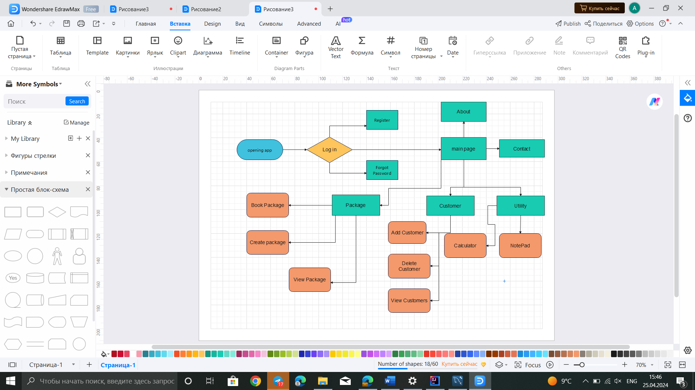

Picture 15. Flow-chart

## Review of used libraries

Swing is a Java Foundation Classes [JFC] library and an extension of the Abstract Window Toolkit [AWT]. Java Swing offers much-improved functionality over AWT, new components, expanded components features, and excellent event handling with drag-and-drop support.

Introduction of Java Swing

Swing has about four times the number of User Interface [UI] components as AWT and is part of the standard Java distribution. By today’s application GUI requirements, AWT is a limited implementation, not quite capable of providing the components required for developing complex GUIs required in modern commercial applications. The AWT component set has quite a few bugs and does take up a lot of system resources when compared to equivalent Swing resources. Netscape introduced its Internet Foundation Classes [IFC] library for use with Java. Its Classes became very popular with programmers creating GUI’s for commercial applications.

Swing is a Set of API (API- Set of Classes and Interfaces)

Swing is Provided to Design Graphical User Interfaces

Swing is an Extension library to the AWT (Abstract Window Toolkit) 5:00 – 5:30 pm

Includes New and improved Components that have been enhancing the looks and Functionality of GUIs’

Swing can be used to build (Develop) The Standalone swing GUI Apps as Servlets and Applets

It Employs model/view design architecture.

Swing is more portable and more flexible than AWT, the Swing is built on top of the AWT.

Swing is Entirely written in Java.

Java Swing Components are Platform-independent, and The Swing Components are lightweight.

Swing Supports a Pluggable look and feel and Swing provides more powerful components.

such as tables, lists, Scrollpanes, Colourchooser, tabbed pane, etc.

Java programming is used to develop different types of applications like window-based applications, web applications, Enterprise applications, or mobile applications. For creating standalone applications, Java AWT API is used. AWT allows programmers to create Graphical User Interface (GUI) for a window-based application.

Java Abstract Window Toolkit (AWT) is an Application Program Interface (API). The components used in Java AWT are platform-dependent. It uses recourses of the operating system that means the view of these components is changed according to the operating system.

Features of AWT

AWT has a set of native user interface components.

It provides various classes for graphical representation of components like font, shape, color.

It provides a robust event-handling model.

It has Layout managers which is helpful for changing window size or screen resolution.

It provides a large range of libraries that can be used for designing graphics for gaming applications or educational applications.

It has data transfer classes through which cut and paste operation can be performed using the local clipboard.

# **Results**

Significant results have been achieved. The developed platform is successfully functioning and working. During the project, deeper knowledge was acquired in learning the Java programming language. The main functionality of the game includes tests, their platforms, search, buttons, graphical interface and photos. It is important to note that the platform is based on the use of the Swing and AWT libraries, which ensures its functioning and stability. Thanks to this library, it was possible to implement all the necessary components and create an exciting game interaction.

# **Conclusion**

With the goal of offering a solid foundation for the efficient management of travel agency operations, this project investigates database design and management in the context of travel agencies. The project starts out by emphasizing how crucial management is to improving customer happiness and operational efficiency. The process of problem definition and analysis entails examining the features of the travel agency industry, determining the main obstacles and needs for system operation, and evaluating the quantity and organization of data.

By using modern SQL features and following best practices in database architecture, the project provides a comprehensive solution for handling database administration demands in travel companies. In hope to provide clients with outstanding experiences in the constantly changing travel industry.